**Display the branch name and assets from all branches in lakhs of**

**rupees and rename the assets column to in lakhs.**

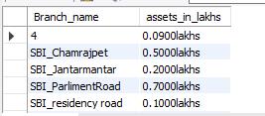

**Find all the customers who have at least two accounts at the same**

**branch (ex.SBI_ResidencyRoad).**



**Create a view which gives each branch the sum of the amount of all the**

**loans at the branch.**

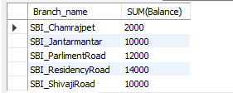

**UPDATE OR ADD RUPEES 1000 TO ACCOUNT BALANCE FOR THE**

**CUSTOMERS WHO ARE RESIDING IN BANGALORE.**

